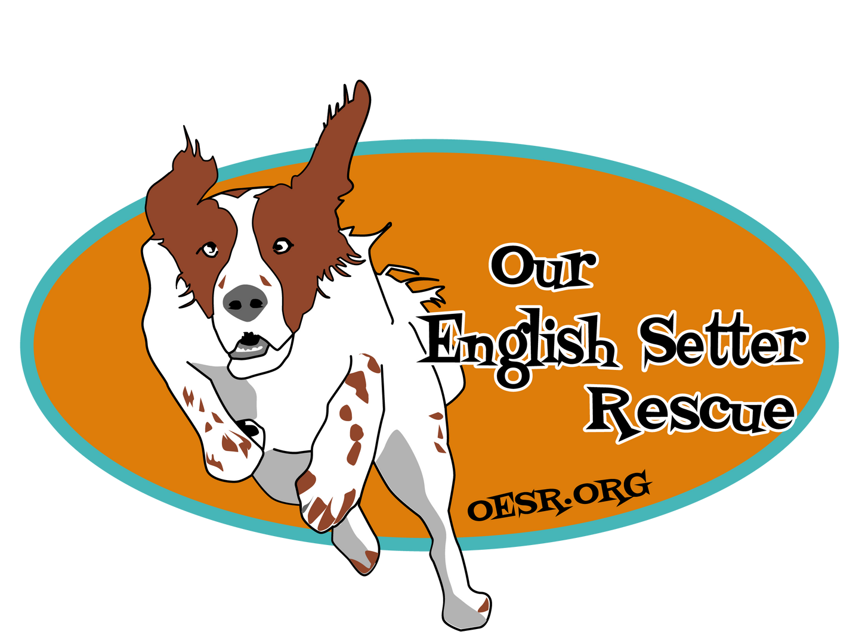

<Sponsor Name> <Sponsor Address>
<City State, Zip>

<Date>

Subject: 5K Sponsorship Request

Dear <Contact Name or Company Name or Both>

I am writing on behalf of Our English Setter Rescue (OESR), a non-profit organization whose purpose is to rescue, foster, and find adoptive homes for our beloved English Setters. OESR is seeking sponsors for our 2nd Annual Virtual 5k, being held on May 14, 2022. It’s a fun event for people across the country, to run, walk, kayak, skate, etc. to help raise funds for OESR.

As a sponsor, your company will have wide exposure with your name and logo on the back of 5k t-shirts and will be promoted on our social media platforms (Facebook, Instagram) and on our website, OESR.org. We have over 9,00 followers on our Facebook page and over 600 volunteers and adopters across the continental U.S.

Over the last two years, we have seen our costs increase significantly. Last year alone, the average cost per dog went up to $756. Your donation is used to provide medical care (vaccinations, parasite and heartworm testing and treatment, other medical needs), to setters in our rescue. We also provide lifetime support for our “forever fosters,” who often require advanced medical procedures. We could not provide these services without generous and caring donors.

I would like to thank you for considering sponsoring OESR’s 5k. Should you have any questions, please contact me at <xxx-xxx-xxxx>, or at <youremail@youremail.com>.

Regards,
<Volunteer Contact Information>
Our English Setter Rescue Volunteer

Tax ID: 27-1801855

PO Box 708

Hilliard OH 43026 oesrinfo@gmail.com oesr.org

